CS628 Full-Stack Development Web App

**PE04 – Cities**

School of Technology & Computing (STC)

City University of Seattle (CityU)

**Before You Start**

* You already created a private GitHub repository for all your programming exercises, “cs628-pe-your_first_name.”
* You allowed your instructor and the Teaching Assistant to access your GitHub repository for programming assignments.
* The GitHub Codespaces may bill your account according to your usage. Check the price at <https://docs.github.com/en/billing/managing-billing-for-github-codespaces/about-billing-for-github-codespaces>. Please pay attention to the storage and core hours of use free of charge for personal accounts.
* Some steps are not explained in the assignment**.**If you are not sure what to do:
  + Consult the resources listed in your course.
  + If you need help solving the problem after a few tries (~15 minutes), ask a TA for help.

**Learning Outcomes**

Students will be able to:

* + Create a React app with Navigation based on their understanding of React Router.

**Problem**

Your task is to develop a React application called "Cities" that allows users to interact with city information. The application should have the following features:

* **Cities List:** Implement a route that displays a list of cities. Each city in the list should be a clickable link that navigates to the individual city's details page.
* **Add City:** Implement a route that allows users to add a new city along with its information. The user should be able to provide the city's name, country, population and other details.
* **City Details:** Implement a nested route under the "Cities List" route that displays detailed information about a specific city. When a user clicks on a city name from the cities list, they should be redirected to the city's details page, where all the information provided about the city is displayed. Utilize the **useParams** hook to fetch and display information based on the city's unique identifier. This city information should be displayed within the same page layout as the "Cities List" page. This means that the city details will replace a designated section of the "Cities List" page's content, while other parts of the layout remain consistent.
* **Redirection:** Implement redirection functionality in any one of the screens. For instance, after successfully adding a city, the user should be redirected back to the cities list.

**Requirements:**

* Use React Router for implementing the different routes in your application.
* Use the **useParams** hook to access the city's id and display the appropriate details on the city's details page.
* Implement at least one instance of redirection, showcasing your understanding of navigation.
* Apply your own styling to make the application visually appealing and user-friendly.
* Organize your components and files in a structured manner for clarity.

**Sample output:**

AddCity Screen:  
  
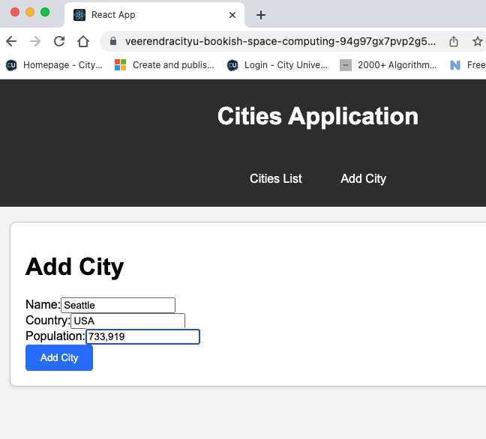

After Adding the application should redirect to Cities Screen:

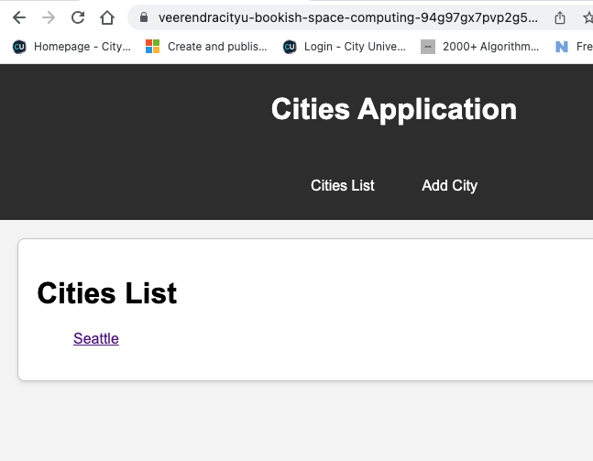

When Clicked on City, it should display City Details on the same page.

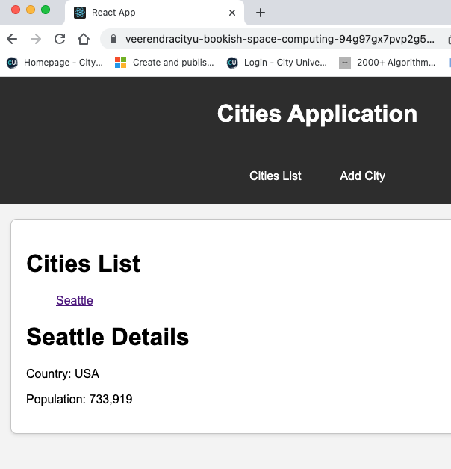

**Submission**

1. Create a GitHub repository for your programming exercises. The repository name will be “cs628-pe-*your_first_name*.”

1

1. Click the Settings menu. Invite your instructor and TA to collaborators.

1

1. Under the repository, create a directory for the programming exercise 1, “PE04-Cities.” For example, the screen below shows the directory created for programming exercise 01.

1. Finish your programming exercise under the PE01 directory.
2. Write a 150-word analysis report to explain how the program works in [README.md](https://www.markdownguide.org/basic-syntax/) in terms of the [input-process-output model](https://press.rebus.community/programmingfundamentals/chapter/input-process-output-model/). The README.md has three level-1 headings – Input, Process, and Output.
3. Please upload the screenshots of your output to your GitHub repository to demonstrate that you have completed the requirements.
4. Submit the link of your GitHub repository to your course shell through your assignment submission.

